H’COLA’s
23rd Annual African American History Festival
February 21-22, 2026 | Apalachicola, FL

2026 SPONSORSHIP FORM

Join Us in Celebrating Over 22 Years of Service & African American History in Apalachicola!
The Hillside Coalition Of Laborers for Apalachicola (H’COLA) is proud to announce our upcoming regional celebration honoring African American History in the beautiful, historic city of Apalachicola, FL.
We invite you to partner with us as a valued sponsor and play a vital role in this milestone event. Sponsorship opportunities are available at three levels, offering your business recognition among thousands of visitors and locals. Your support directly funds the celebration and provides scholarships for graduating seniors in our community.
If you’ve sponsored us before, thank you! We’ll continue to use your logo and information on file unless you’d like to update it. New sponsors, please include your logo and corporate details with your contribution.
Name as you want it to appear: _________ ________________________________________

Contact Name:_________________________________ Notes___________________________

Phone #_______________________________Email: ___________________________________

Please choose your sponsorship level:
- Platinum $1000.00
Name and/or logo included in all media advertisements. Corporate logo included in festival thank-you and linked to our social media outlets and website. Must meet ad deadline! Exclusive logo and name on Main Stage Banner. Two (2) Festival t-shirts. ____ I do not want shirts. OR _________ Shirt Sizes
- Silver $500.00
Larger ad space on the Sponsor Banner at the festival. Included in festival thank-you ad. One (1) Festival t-shirt ___ I do not want shirt OR _____ Shirt Size

Patron $250.00
Name printed on Sponsor Banner located at the festival. Included in festival thank-you ad.
- Friend $100.00 - $249.00 Listed in festival thank-you ad.

Several ways to pay: Pay online at our website www.hcola.org, Make your check or money order payable to H’COLA. Contact any H’COLA member for pickup or mail to the address above. Please do not mail cash. You may also pay via CashApp. Thank you in advance for your support. H’COLA is a 501(c)(3) organization. Deadline is January 15, 2026.

For additional information, please visit our website or contact any of the following members.
Tami Ray-Hutchinson 850.653.7515 | Elinor Mount-Simmons 850.323.0544 | Fonda Davis, Sr. 850.370.6437 | Brenda Ash 850.653.3345 | Soudra Davis 850.323.0883| Sherry O’Neal 850.323.1021 Melissa West 850.323.1040 | LaTrina Lockley 850.296.6764 | Greg Perkins 727.771.3960

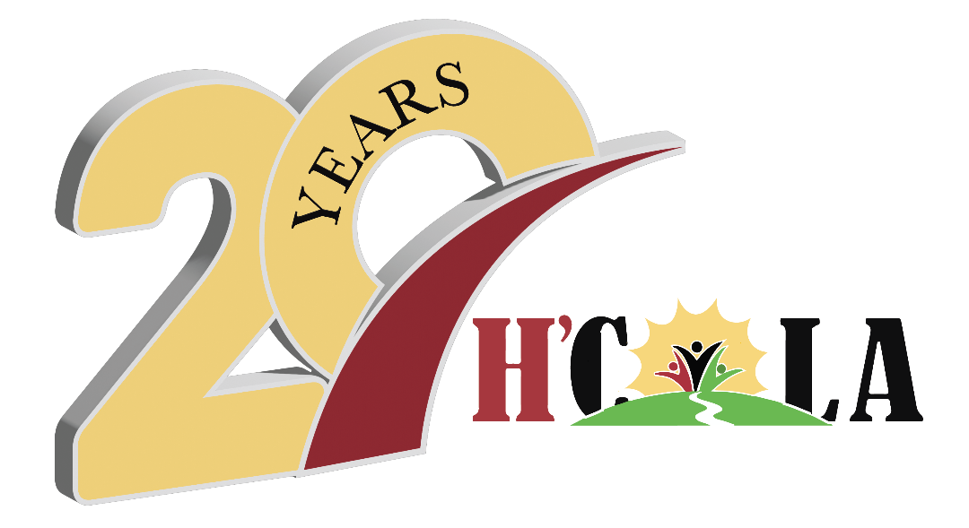
Celebrating over 20 years
of service!

Post Office Box 764
Apalachicola, FL 32329
hcola.fl@gmail.com
www.hcola.org

.

H’C O L A

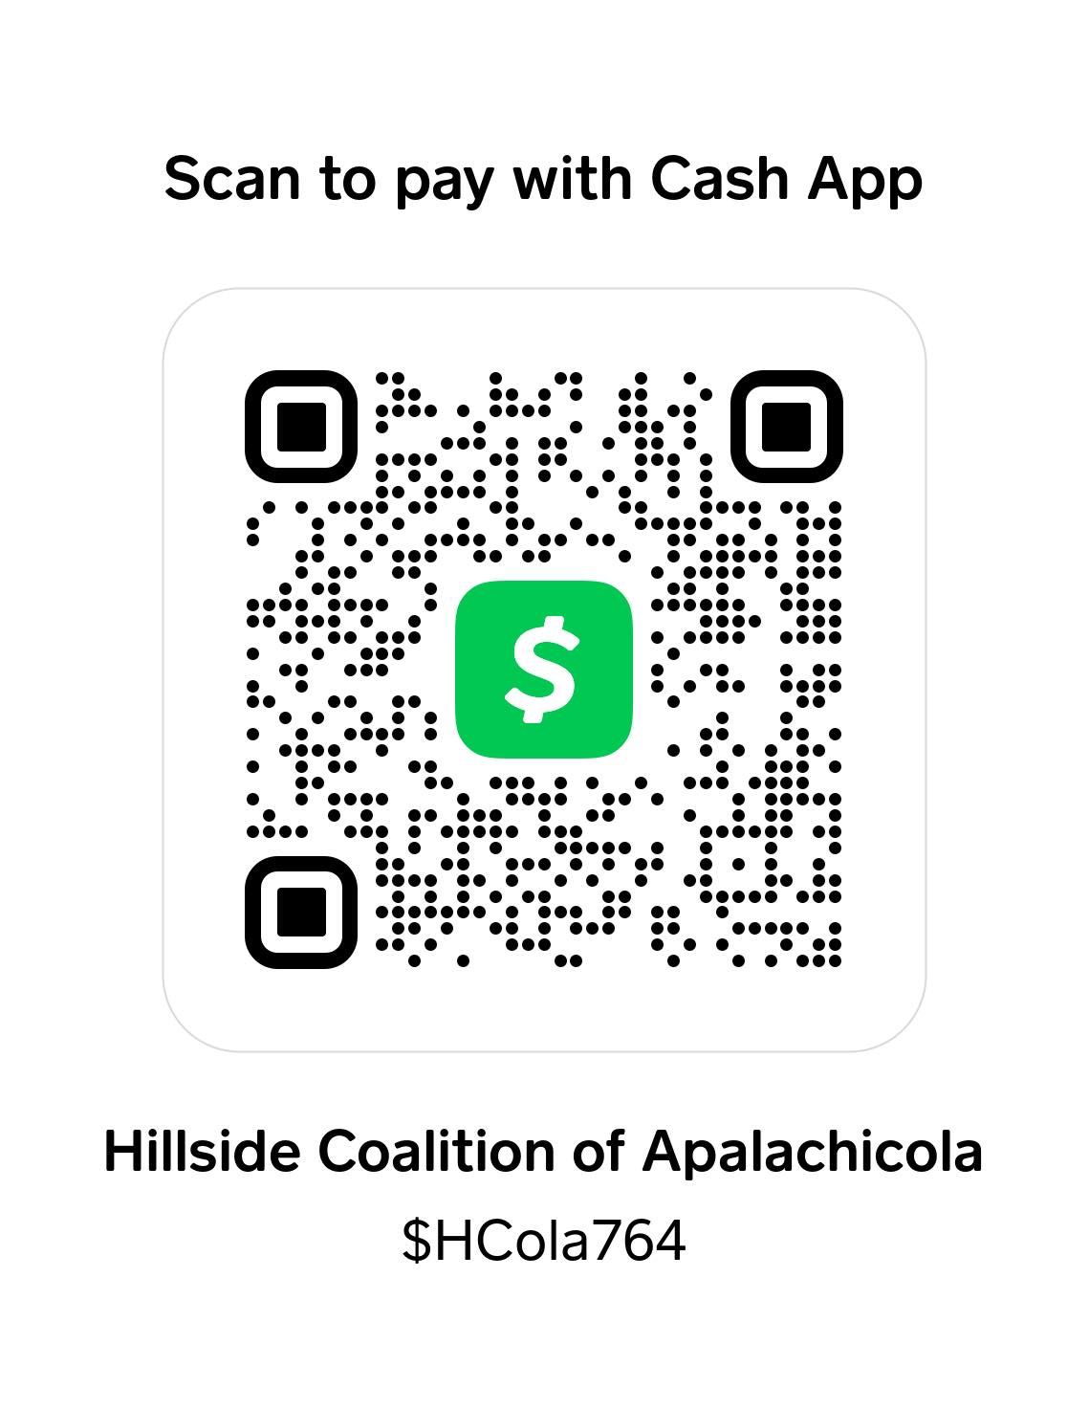

H’C O L A H’COLA, “Working toward the betterment of our community”

