H’COLA’s 23rd Annual African American History Festival
February 21-22, 2026 | Apalachicola, FL
2026 FOR-PROFIT VENDOR SPACE RESERVATION FORM

Vendor Name: ____________________________________________________________
Contact Person: ____________________________________________________________

Mailing Address: ____________________________________________________________
____________________________________________________________
____________________________________________________________

Email Address: ____________________________________________________________

Best Contact Number: __________________________ Alternate Number; __________________

Please select SPACE SIZE/TYPE & FEE:
12x12 Tent 2 Tent Spaces Enclosed Trailer Food Truck or MFD Unit
$100.00 $150.00 $200.00 $200.00

Please select VENDOR TYPE:
Arts/Crafts Clothing Accessories Games/Recreation

Food/Drinks Other/Specify: __________________________

Special Handling: ____________________________________________________________
____________________________________________________________
____________________________________________________________
Vendor fee includes water, limited 110a electric service, and overnight security. If you require more than 110a service, you will need to provide your own generator. ____Please Initial Here

***Food Trucks & Enclosed Trailers must be in place no later than 7p Thursday 2/19. For all other vendors setup is on Friday and must be complete by 7p on 2/21. No vehicles allowed inside the gate after 9pm on Friday. No exceptions. _______Please Initial Here

***TOY GUNS of any type are strictly prohibited. You will be asked to leave and forfeit any deposits or fees paid. ________________Please Initial Here

*** In an effort to maximize vendor profitability, H’COLA reserves the right to limit the number of vendors selling the same items. Please be specific and list all items you plan to sell.
________________Please Initial Here

Vendor space is limited and reserved on a first-come, first-served basis. You will be assigned a space number and setup instructions the week of the event.

Thank you in advance for your support. H’COLA is a 501(c)(3) organization. Deadline is February 1, 2026. Payment may be remitted by check or money order to PO Box 764, Apalachicola, FL 32329, payment online, or by Cash App or as shown to the left.

For additional information, please visit our website or contact any of the following members:
Tami Ray-Hutchinson 850.653.7515 | Elinor Mount-Simmons 850.323.0544 | Fonda Davis, Sr. 850.370.6437 | Brenda Ash 850.653.3345 | Soudra Davis 850.323.0883| Sherry O’Neal 850.323.1021 Melissa West 850.323.1040 | LaTrina Lockley 850.296.6764 | Greg Perkins 727.771.3960

I have read, understand, and agree to the terms.

Vendor Signature _____________________________ Printed Name________________________


Celebrating over 20 years
of service!

Post Office Box 764
Apalachicola, FL 32329
hcola.fl@gmail.com
www.hcola.org

.

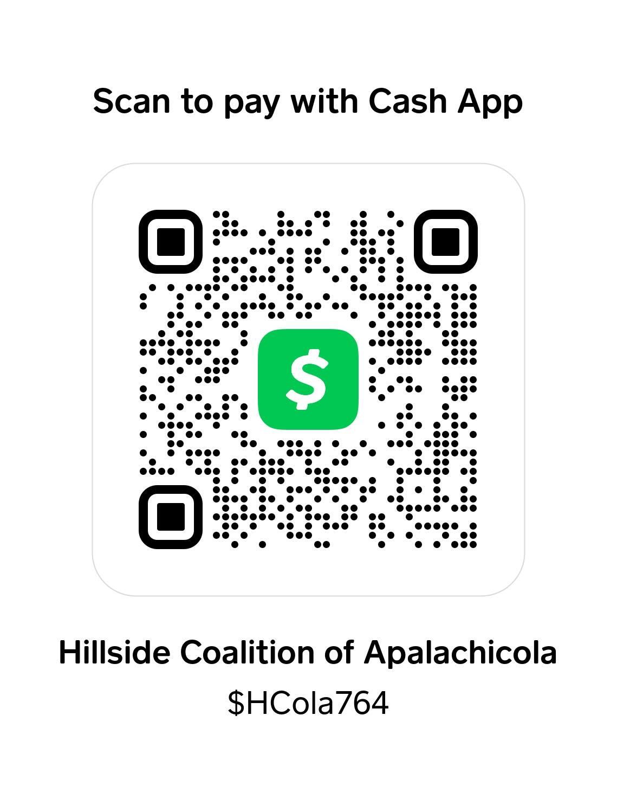

H’C O L A

