H’COLA’s
23rd Annual African American History Festival
February 21-22, 2026 | Apalachicola, FL

2026 NON-PROFIT VENDOR SPACE RESERVATION FORM

Organization Name: ____________________________________________________________
Contact Person: ____________________________________________________________

Mailing Address: ____________________________________________________________
____________________________________________________________
____________________________________________________________

Email Address: ____________________________________________________________

Best Contact Number: __________________________ Alternate Number; __________________

Please choose:
Educational Informational Health-related

Please note as a non-profit vendor, you are not charged a fee. Your booth must be informational, educational, or health-related and you are prohibited from selling any items. You will be allotted one (1) 10X10 Space. You must provide your own tents, tables, chairs, etc. Tables should not be longer than 6’. Water and limited 110a Electricity will be provided. If you require additional service, you must provide your own generator.

Special Handling: ____________________________________________________________
____________________________________________________________
____________________________________________________________

Thank you in advance for your support. H’COLA is a 501(c)(3) organization. Deadline is February 1, 2026

For additional information, please visit our website or contact any of the following members:
Tami Ray-Hutchinson 850.653.7515 | Elinor Mount-Simmons 850.323.0544 | Fonda Davis, Sr. 850.370.6437 | Brenda Ash 850.653.3345 | Soudra Davis 850.323.0883| Sherry O’Neal 850.323.1021 | Melissa West 850.323.1040 | LaTrina Lockley 850.296.6764 | Greg Perkins 727.771.3960

Tami L. Ray-Hutchinson
Secretary/Publicist
tamirh68@yahoo.com
850.653.7515

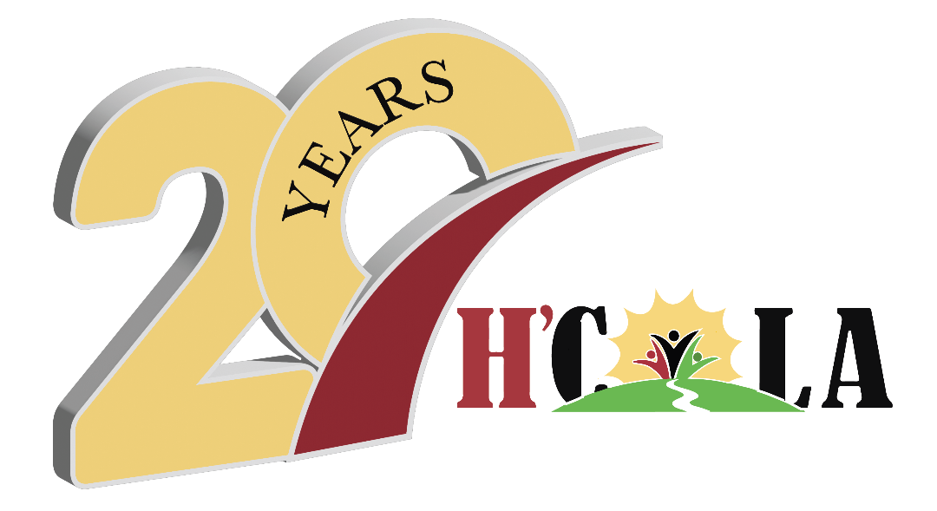
Celebrating over 20 years
of service!

Post Office Box 764
Apalachicola, FL 32329
hcola.fl@gmail.com
www.hcola.org

.

H’C O L A

H’COLA, working toward the betterment of our community”

