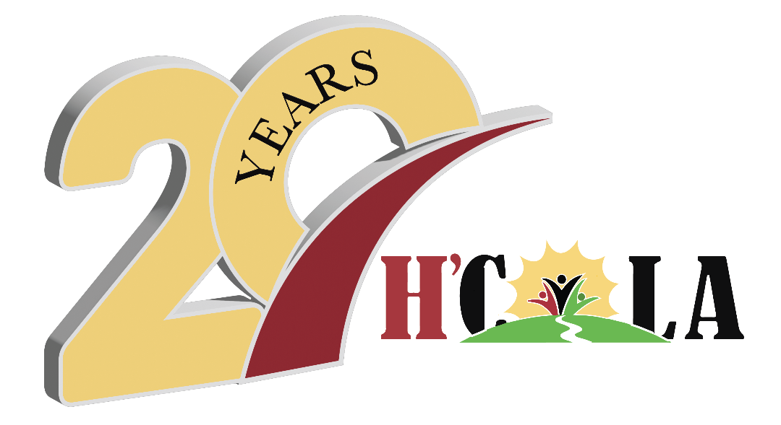
H’COLA’s
23rd Annual African American History Festival
February 21-22, 2026 | Apalachicola, FL

2026 PARADE ENTRY FORM

Dear Perspective Parade Participant,

The Hillside Coalition Of Laborers for Apalachicola (H’COLA) is excited to announce plans for our regional celebration of African American History. We welcome you to show off your talent and/or creativity by being a part of our parade.

Saturday, February 21st is the main day of attractions and kicks off with our annual festival parade. The parade begins at Noon, with line-up at 11.30am at the Community Services Center at 192 -14th St (Coach Wagoner Blvd). The parade route heads from 14th Street, down MLK, and ends at the festival in Franklin Square. Please contact one of us if you have questions or need additional information.

We want to encourage you to join us. Please let us know what you need from H’COLA to make this happen. Contact either of us for more information concerning the parade or the festival. Fill out the bottom portion and return. Deadline for entry is February 7, 2025.

Thank you in advance for your participation.

Parade Coordinators,

Soudra Brenda
Soudra Davis Brenda Ash
850.323.0883 850.653.3345

__________________________________________________________

Name &/or Organization ________________________________________________________

Phone: _________________________________ Email: _________________________________

_______Float ________Boat ________Car ________Golf Cart ______Walking

_______Band ________Dance ___________Politician ________Non-Profit/Informational

H’COLA, “Working toward the betterment of our community”

Celebrating over 20 years
of service!

Post Office Box 764
Apalachicola, FL 32329
hcola.fl@gmail.com
www.hcola.org

.

H’C O L A

